**STAT 46700/CS 59000 Topics in Data Science Spring 2025**

**Lab 1  
Vaishak Balachandra (0037831852)**

**Q.N. 1)** Flight times (scheduled and actual) and taxi-out times of all Delta outbound flights from Atlanta in October 2004 are provided in the link below.

<http://users.stat.ufl.edu/~winner/data/atltime1004a.dat>

Variables/Columns

Flight Date 1-2

Flight Number 6-9

Tail Number 13-18

Destination city 22-24

Taxi-out time (minutes) 28-31

Scheduled flight time 35-38

Actual flight time 42-45

distance (miles) 49-52

Note that cancelled flights will have actual flight time=0.

1. Import the data in R without saving in your computer
2. How many flights were cancelled? Delete all the cancelled flights.
3. How many destinations does the Delta flight have from Atlanta?

> ########## q1

> # a

> url <- "https://users.stat.ufl.edu/~winner/data/atltime1004a.dat"

> q1 <- read.table(url)

> head(q1,6)

V1 V2 V3 V4 V5 V6 V7

1 1 833N619DL ABQ 26 204 214 1250

2 1 1125N660DL ABQ 18 211 204 1250

3 1 1589N678DL ABQ 23 206 212 1250

4 2 833N659DL ABQ 18 204 194 1250

5 2 1125N656DL ABQ 23 211 210 1250

6 2 1589N665DN ABQ 19 206 212 1250

> tail(q1)

V1 V2 V3 V4 V5 V6 V7

17807 30 1455N933DL VPS 13 73 59 250

17808 30 1803N980DL VPS 14 70 63 250

17809 31 370N973DL VPS 18 71 69 250

17810 31 1011N972DL VPS 19 77 69 250

17811 31 1455N911DL VPS 15 73 63 250

17812 31 1803N907DL VPS 37 70 85 250

> dim(q1)

[1] 17812 7

> # b

> names(q1)

[1] "V1" "V2" "V3" "V4" "V5" "V6" "V7"

> sum(q1$V6 == 0)

[1] 88

> cat("There are 88 flights got cancelled")

There are 88 flights got cancelled

> # or

> data_new = subset(q1, q1$V6==0)

> dim(data_new)

[1] 88 7

> cat("There are 88 flights got cancelled")

There are 88 flights got cancelled

> summary(q1)

V1 V2 V3 V4 V5

Min. : 1 Length:17812 Length:17812 Min. : 0.00 Min. : 48.0

1st Qu.: 8 Class :character Class :character 1st Qu.: 15.00 1st Qu.: 84.0

Median :16 Mode :character Mode :character Median : 19.00 Median :106.0

Mean :16 Mean : 20.75 Mean :128.4

3rd Qu.:24 3rd Qu.: 25.00 3rd Qu.:138.0

Max. :31 Max. :100.00 Max. :580.0

V6 V7

Min. : 0.0 Min. : 132.0

1st Qu.: 83.0 1st Qu.: 399.0

Median :106.0 Median : 568.0

Mean :127.4 Mean : 711.8

3rd Qu.:141.0 3rd Qu.: 783.0

Max. :627.0 Max. :4496.0

> # c

> length(table(q1$V3))

[1] 93

> cat("93 flights from Atlanta")

93 flights from Atlanta

**Q.N. 2)** Although all cases of AIDS in England and Wales must be reported to the Communicable Disease Surveillance Centre, there is often a considerable delay between the time of diagnosis and the time that it is reported. In estimating the prevalence of AIDS, account must be taken of the unknown number of cases which have been diagnosed but not reported. Under the Rich source of data in the Brightspace you will see the second data set “aids” .( You can access the data from the Data folder in the Brightspace too). The data set here records the reported cases of AIDS diagnosed from July 1983 and until the end of 1992.

a) Import the dataset in R.

b) Determine the dimension of the dataset.

c) List the variables included in the dataset.

d) Calculate the summary statistics of the delay.

e) Draw a histogram of the delay.

f) Aggregate the data based on year to calculate the mean

g) Aggregate the data based on year and quarter to calculate the mean

> ########## q2

> # a

> # file.choose()

> q2 <- read.csv("C:\\Users\\PNW_checkout\\Downloads\\sem2\\0. Coursework\\Data science\\Lab\\Lab 1\\aids.csv")

> head(q2)

X year quarter delay dud time y

1 1 1983 3 0 0 1 2

2 2 1983 3 2 0 1 6

3 3 1983 3 5 0 1 0

4 4 1983 3 8 0 1 1

5 5 1983 3 11 0 1 1

6 6 1983 3 14 0 1 0

> attach(q2)

> # b

> dim(q2)

[1] 570 7

> cat("There are 570 rows and 7 columns")

There are 570 rows and 7 columns

> # c

> colnames(q2)

[1] "X" "year" "quarter" "delay" "dud" "time" "y"

> # d

> summary(delay)

Min. 1st Qu. Median Mean 3rd Qu. Max.

0.00 8.00 20.00 20.07 32.00 41.00

> # e

> hist(delay, main = "Histogram of Delay", col = rainbow(7))

> # f

> ?aggregate

> aggregate(data.frame(q2), by = list(year), FUN = mean)

Group.1 X year quarter delay dud time y

1 1983 15.5 1983 3.5 20.06667 0.0000000 1.5 0.800000

2 1984 60.5 1984 2.5 20.06667 0.0000000 4.5 1.633333

3 1985 120.5 1985 2.5 20.06667 0.0000000 8.5 3.583333

4 1986 180.5 1986 2.5 20.06667 0.0000000 12.5 7.183333

5 1987 240.5 1987 2.5 20.06667 0.0000000 16.5 10.016667

6 1988 300.5 1988 2.5 20.06667 0.0000000 20.5 13.566667

7 1989 360.5 1989 2.5 20.06667 0.0500000 24.5 15.483333

8 1990 420.5 1990 2.5 20.06667 0.3000000 28.5 17.850000

9 1991 480.5 1991 2.5 20.06667 0.5666667 32.5 18.300000

10 1992 540.5 1992 2.5 20.06667 0.8333333 36.5 17.233333

> # g

> aggregate(data.frame(q2), by = list(year, quarter), FUN = mean)

Group.1 Group.2 X year quarter delay dud time y

1 1984 1 38 1984 1 20.06667 0.00000000 3 0.9333333

2 1985 1 98 1985 1 20.06667 0.00000000 7 3.1333333

3 1986 1 158 1986 1 20.06667 0.00000000 11 5.4666667

4 1987 1 218 1987 1 20.06667 0.00000000 15 8.9333333

5 1988 1 278 1988 1 20.06667 0.00000000 19 11.6000000

6 1989 1 338 1989 1 20.06667 0.00000000 23 14.9333333

7 1990 1 398 1990 1 20.06667 0.20000000 27 18.7333333

8 1991 1 458 1991 1 20.06667 0.46666667 31 18.0666667

9 1992 1 518 1992 1 20.06667 0.73333333 35 20.6666667

10 1984 2 53 1984 2 20.06667 0.00000000 4 1.0000000

11 1985 2 113 1985 2 20.06667 0.00000000 8 2.6666667

12 1986 2 173 1986 2 20.06667 0.00000000 12 8.0000000

13 1987 2 233 1987 2 20.06667 0.00000000 16 9.4000000

14 1988 2 293 1988 2 20.06667 0.00000000 20 14.0666667

15 1989 2 353 1989 2 20.06667 0.00000000 24 14.6000000

16 1990 2 413 1990 2 20.06667 0.26666667 28 16.3333333

17 1991 2 473 1991 2 20.06667 0.53333333 32 17.5333333

18 1992 2 533 1992 2 20.06667 0.80000000 36 21.2000000

19 1983 3 8 1983 3 20.06667 0.00000000 1 0.8000000

20 1984 3 68 1984 3 20.06667 0.00000000 5 2.0000000

21 1985 3 128 1985 3 20.06667 0.00000000 9 4.2000000

22 1986 3 188 1986 3 20.06667 0.00000000 13 7.2666667

23 1987 3 248 1987 3 20.06667 0.00000000 17 10.2000000

24 1988 3 308 1988 3 20.06667 0.00000000 21 14.9333333

25 1989 3 368 1989 3 20.06667 0.06666667 25 16.8666667

26 1990 3 428 1990 3 20.06667 0.33333333 29 17.3333333

27 1991 3 488 1991 3 20.06667 0.60000000 33 20.4000000

28 1992 3 548 1992 3 20.06667 0.86666667 37 18.2000000

29 1983 4 23 1983 4 20.06667 0.00000000 2 0.8000000

30 1984 4 83 1984 4 20.06667 0.00000000 6 2.6000000

31 1985 4 143 1985 4 20.06667 0.00000000 10 4.3333333

32 1986 4 203 1986 4 20.06667 0.00000000 14 8.0000000

33 1987 4 263 1987 4 20.06667 0.00000000 18 11.5333333

34 1988 4 323 1988 4 20.06667 0.00000000 22 13.6666667

35 1989 4 383 1989 4 20.06667 0.13333333 26 15.5333333

36 1990 4 443 1990 4 20.06667 0.40000000 30 19.0000000

37 1991 4 503 1991 4 20.06667 0.66666667 34 17.2000000

38 1992 4 563 1992 4 20.06667 0.93333333 38 8.8666667

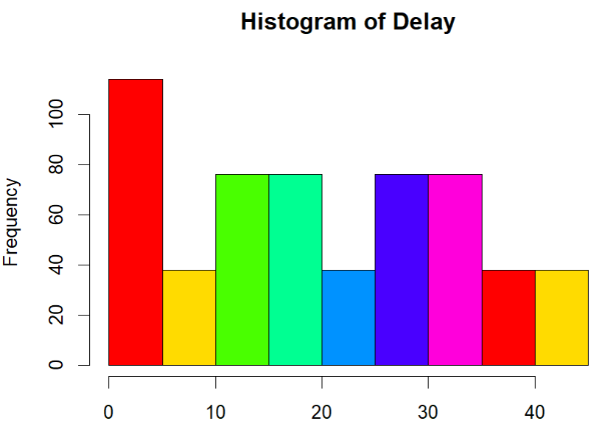

**Q.N. 3)** Data from four different regions (*region*) related to four different products are provided in the Brightspace. Import the data in R and choose from East to display the distribution by product type.

> ########## q3

> # install.packages("readxl")

> library(readxl)

> # file.choose()

> q3 <- read_xlsx("C:\\Users\\PNW_checkout\\Downloads\\sem2\\0. Coursework\\Data science\\Lab\\Lab 1\\region.xlsx", sheet = "East")

> head(q3)

# A tibble: 6 × 5

Month `Porduct - A` `Porduct - B` `Porduct - C` `Porduct - D`

*<chr>* *<dbl>* *<dbl>* *<dbl>* *<dbl>*

1 Jan 1860 1202 1371 1973

2 Feb 1191 1811 1618 1289

3 Mar 1890 1724 1088 1880

4 Apr 1804 1732 1964 1541

5 May 1913 1937 1613 1357

6 Jun 1016 1895 1229 1285

> dim(q3)

[1] 12 5

> names(q3) = c("Month", "Product_A","Product_B","Product_C","Product_D")

> boxplot(q3[,-1], col = rainbow(3), main = "Boxplot Distribution of the Region \nbased on Data Type")

